**Solar System Scale**

Today in Science class, Mr. Smith did a demonstration to show us the scale of the solar system.

Solar Scale

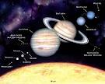 In this demonstration, Mr. Smith spaced us out all over the school property to show us to scale how far apart the planets of the solar system are if the sun was 3.5 inches in diameter. I was Mercury, so I was very, very close to the sun. The drawing that represented Mercury was a pencil dot on a piece of paper. It was very small.